Name: ___________________________________ Teacher: _____________________ Period: ____________ Date Due: _________________

Lab Report Worksheet- Have all of the requirements been met? (number of pages are recommendations)
- Title (1 page)- Name of the lab, your name, name of the school, period, date, and instructor. This is the coversheet of your report.
- Abstract (150 to 250 words)- (What am I investigating? The entire report will always reflect the objective.) Summarize each section of the lab report in one sentence per section. Put these sentences together into a paragraph to form your abstract:
(Write this section after you have completed the work below)
Introduction:____________________________________________________________________________________________________
Methods/Procedure:______________________________________________________________________________________________
Results/Data:____________________________________________________________________________________________________
Calculations:____________________________________________________________________________________________________
Questions and Problems:___________________________________________________________________________________________
Error Analysis Conclusions:________________________________________________________________________________________
- Introduction ( ½ to 1 page)- Describe what concept(s) the lab explores, the main objective of the lab, what actions you performed, and how those actions helped you achieve the lab objective.
What concept are you exploring during the lab experiment? ______________________________________________________________
What key terms and vocabulary words were used during the lab?__________________________________________________________

- Methods/Procedure (1 page)- Document your experimental procedure in enough detail that someone else could repeat your work. This should include a list of all materials used, a diagram of the lab setup if appropriate, and the steps taken to accomplish the lab (paragraphs preferred, but organized, ordered lists of instructions are acceptable with list items in complete sentences.)
List all materials used.

Steps taken. Provide enough information that another person could easily replicate your work.

- Results/Data (1 page)- Put your data into tables and graphs. Arrange the results section in an organized fashion.
Graphs. Titled and properly labeled with all areas, provided appropriate units.
Example
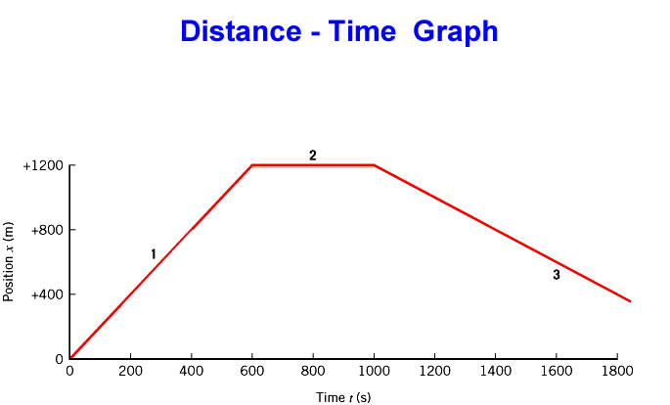
Data Tables. Titled, organized and labeled with units.

Example
Position and Time Table
Trial | Distance  (Meters) | Time  (Sec) | Speed  (Meters/Sec)
1 | 1 | 1 | 1
2 | 1 | 2 | 0.5

- Calculations (1 page)-You should show how calculations are carried out. Give the equation used and show how your values are substituted into it. Label each value with units and identification of what it represents. Type calculations in math editor.
Example
Given Equation Rearrange (if needed) Calculate
s= 2m/s s=d/t d=s*t d=2m/s * 5s = 10m
d=?
t= 5s

- Questions and Problems ( ½ to 1 page)-Guiding questions that assist you in development of your conclusion. Answer questions in complete sentences and in such a way that the question that was asked is understood.

- Error Analysis/Conclusion ( ½ to 1 page)
Explain whether results support the objective, with supporting details referenced from the results section and why.
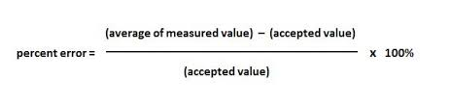_____________________________________________________________________________________________________________
_____________________________________________________________________________________________________________
Discuss any problems encountered, uncertainty in measurements (error analysis), comparison to others performing the lab, and possible improvement opportunities. _______________________________________________________________________________________ ______________________________________________________________________________________________________________
Hints: Neatness count. Use Times New Roman or Arial 12 pt font. Write in the 3rd person, avoid 1st and 2nd person references such as I, we, you, and you (understand).
Adapted from NC State University's LabWrite Program, © 2004 NC State University
Updated 12/1/14

